**SECTION – 1**

**GIT BRANCHING**

**Objective: Commit HTML, CSS & JavaScript assignments into GIT.**

**SECTION-1 (HTML assignments)-Steps to follow:**

21. First take a backup of your assignments & projects. This is required because due incorrect GIT operation you may lose your files.

22. Create an empty directory 'Assignments & cd to 'Assignments.

23. Create a file README.txt inside 'Assignments' & write few lines about the contents of

'Assignments' folder.

24. Commit README.txt file.

25. Now create a new branch 'html-assignments.

26. Switch to 'html-assignments' branch.

27. Copy all HTML assignments inside 'Assignments’ folder.

28. Commit HTML assignments into html-assignments' branch.

29. Make minor changes into few files belonging to 'html-assignments' branch.

30. Commit those changed files.

31. Switch to master branch.

32. Make minor changes into README.txt file & commit those changes into master.

33. Again switch to 'html-assignments branch.

34. Make minor changes into few files belonging to "html-assignments' branch.

35. Commit those changes.

36. Switch to master.

37. Merge 'html-assignments branch into master. Confirm all html assignments are in master.

38. Finally delete the 'html-assignments' branch.

**QUERY TILL STEPS: 1-28**

Till Committing HTML assignments into html-assignments' branch.

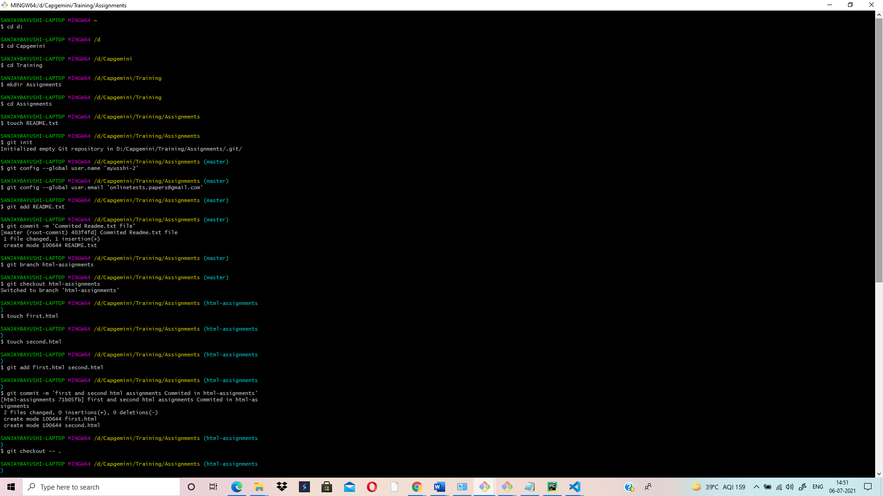

**QUERY TILL STEPS: 27-37 (**Before Deleting html-assignments Branch)

TILL MERGING OF html-assignments branch to master branch:

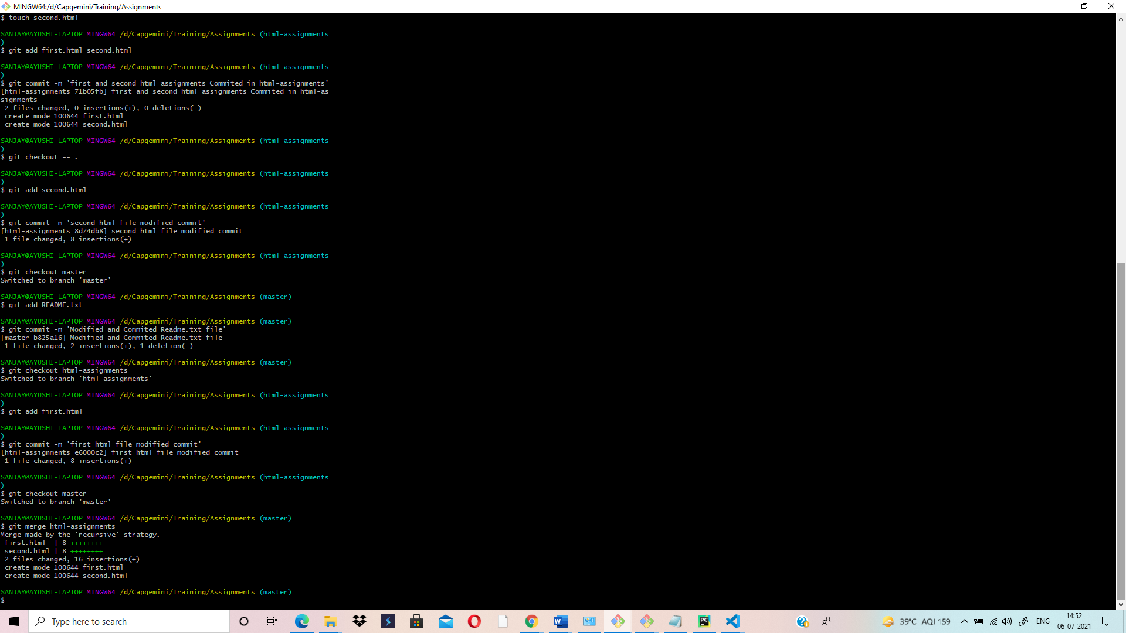

**QUERY TILL STEPS: 28-38**

AFTER DELETING html-assignments branch-(Last Step)

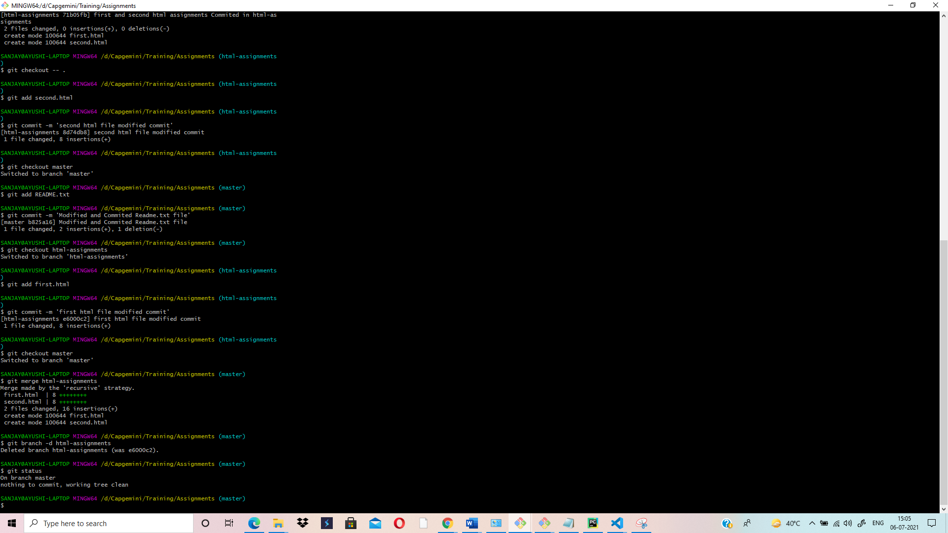

**ASSIGNMENTS FOLDER – (SECTION-1):**

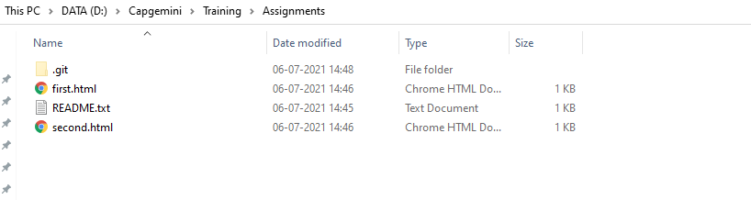

**TEXT EDITOR SCREENSHOT AFTER ADDING MINOR CHANGES INTO FEW FILES BELONGING TO HTML-ASSIGNMENTS BRANCH: TILL STEP - 34**

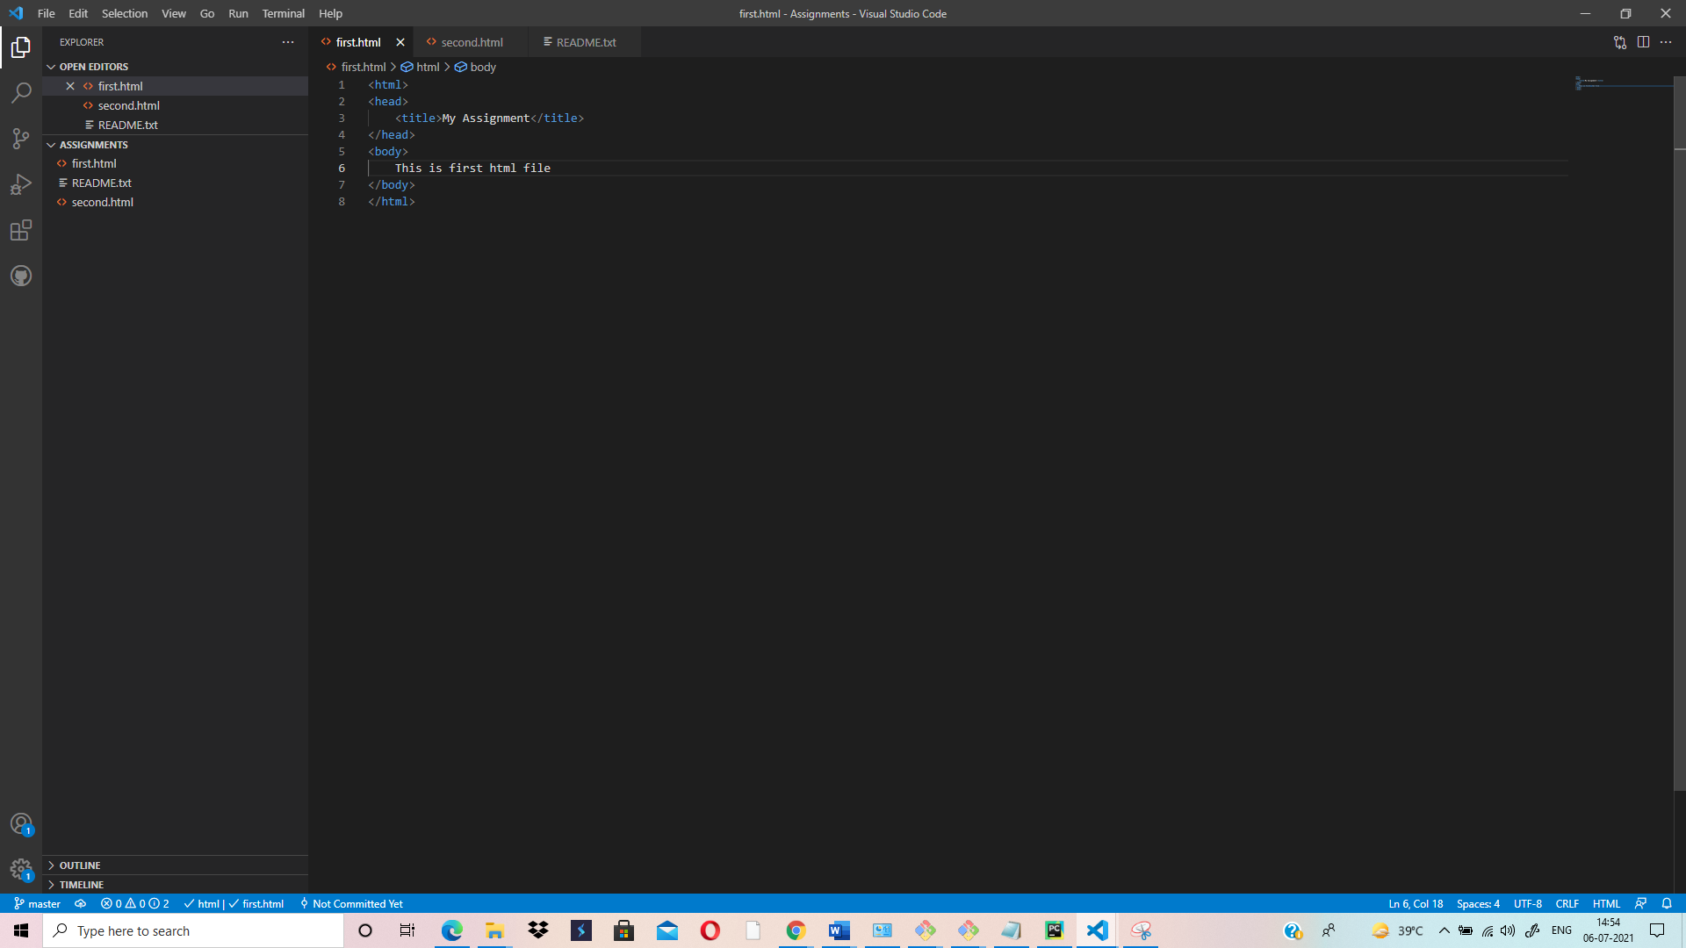

**TEXT EDITOR SCREENSHOT AFTER MERGING-(TILL LAST STEP)**

